**HTML basic syntax structure:**

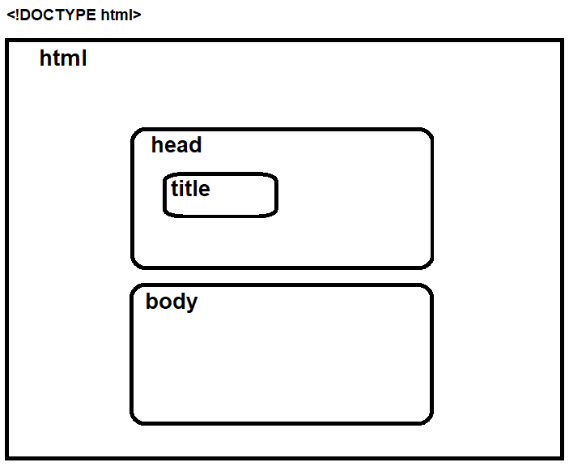Doctype, html, inside it [head, inside it (title) & body].

**Common Tags/Elements [all inside the body tag]:**

**NOTE:** To comment a line in HTML most IDEs has the shortcut Ctrl + /.

**Self Closing tags:**

<br> <hr> <img src="img_girl.jpg">

other attributes: alt="Girl in a jacket" width="500" height="600"

**Non-self Closing Tags:**

<h1> <h2> <h6> <p> <em> <strong>

<ol> {<li>} <ul> {<li>}

<a href="http:www.google.com">Go to Google!</a>

**Note1:** href inside a tag is called attribute.

**Note2:** instead of the “Go to Google!” text, we can put <p> or <h1> or other tags as a link text.

**Note3:** Relative path is relative to the current html location.

E.g. <a href="../first_link/about.html">

../ means go up one step

**Note4:** Absolute path is not relative to any html location.

E.g. <a href="http:www.google.com">

In case an intersite site link, it should start with “*http:”*

<form> we can add texts or <br> before or after each child tag as needed:

<input type=”text” name=”firstname”>

<input type=”date” name=”birthday”>

<input type=”email” name=”email” required>

<input type=”password” name=”password” minlength=”5”>

<input type=”radio” name=”gender”>

<input type=”checkbox” name=”gender”>

<select>

<option value=”Volvo” name=”volvo”></option>

<option value=”Toyota” name=”toyota”></option>

</select>

<select multiple>

<option value=”VX234” name=”vx234”></option>

<option value=”Highlander” name=”highlander”></option>

</select>

< input type=”submit” value=”Register!”>

<input type=”reset”>

**Note1:** input child tag inside <form> is self closing tag.

**Note2:** with radio type, we can have multiple ones, and if they have all the same name, user then can only pick one.

**Note3:** <form> tag could have an *action* attribute. E.g. <form action=”todo.php”> so it is asking to start todo.php script in the server when the form is submitting.

**Note4:** name attribute is important in the forms HTML pages, since it is used to gather user inputs and selections in the form when pressed on Submit button. [With the default method attribute in “form” is GET (<form method=”GET”>) then these names as well as the user inputs for them will appear in the URL “Query String” after pressing Submit button, in order to be sent to the server (*names will be called PROPERTIES and inputs/selections will be called VLUES in the query*). If we put the method attribute of “form” as POST (<form method=”POST”>) then these info (names and their user inputs and selects) will be attached to the body of the request (POST more secure)].

**Note4-a:** with the radio button type of the input, we’ve better to add the value attribute for each one, so it will be combines with the name in the URL query string when submitting. On the other hand, with the select tag, we’ve better to add the name attribute to the select tag itself so it will be combined with the value of the user selection in the URL query string when submitting.

<div> tag is a block element, it allows us to add styles and divide up the content into each different section, so that, each section of our Web site, can have its own little box. [useful for CSS]

<span> tag is a inline element, it does the same thing except we can just add it to surround a specific tag or element or text..etc. - partially or fully, so we can add some styles only to the part inside it.

**Note:** Both <div> and <span> are tools, we use when we want to have an invisible container, around a

piece of element in our HTML code, that perhaps you want to add some style to or have some specific functionality to.

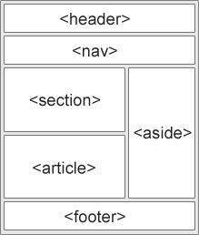 [<header>](https://www.w3docs.com/learn-html/html-header-tag.html)

[<footer>](https://www.w3docs.com/learn-html/html-footer-tag.html)

[<nav>](https://www.w3docs.com/learn-html/html-nav-tag.html)

[<section>](https://www.w3docs.com/learn-html/html-section-tag.html)

[<article>](https://www.w3docs.com/learn-html/html-article-tag.html)

[<table>](https://www.w3docs.com/learn-html/html-tables.html)

|  |
| --- |
|  |